# Terms and Conditions

# FRONT COVER:

## LEGAL NOTICE

The Publisher has strived to be as accurate and complete as possible in the creation of this report, notwithstanding the fact that he does not warrant or represent at any time that the contents within are accurate due to the rapidly changing nature of the Internet.

While all attempts have been made to verify information provided in this publication, the Publisher assumes no responsibility for errors, omissions, or contrary interpretation of the subject matter herein. Any perceived slights of specific persons, peoples, or organizations are unintentional.

In practical advice books, like anything else in life, there are no guarantees of income made. Readers are cautioned to reply on their own judgment about their individual circumstances to act accordingly.

This book is not intended for use as a source of legal, business, accounting or financial advice. All readers are advised to seek services of competent professionals in legal, business, accounting and finance fields.

You are encouraged to print this book for easy reading.

# Table Of Contents

Foreword

Chapter 1:

***Dog Care Basics***

Chapter 2:

***What Items Do You Need For Your Dog***

Chapter 3:

***The Vet Is Your Friend***

Chapter 4:

***Caring For An Elderly Dog***

Chapter 5:

***Caring For A Disabled Dog***

Chapter 6:

***Caring For Small Dogs***

Chapter 7:

***Caring For Big Dogs***

Chapter 8:

***The Dangers Of Not Caring For Your Best Friend***

Wrapping Up

# Foreword

For some owners, having a dog as a pet is similar to having a child although physically there is really no comparison, but emotionally, this really is the case, as dogs are feeling creatures and thus deserve care and love too. Thus, in the quest to be a good and caring owner, the owner should be able to perform some very basic actions that showcase this caring attitude, which will be well received and enjoyed by the pet.

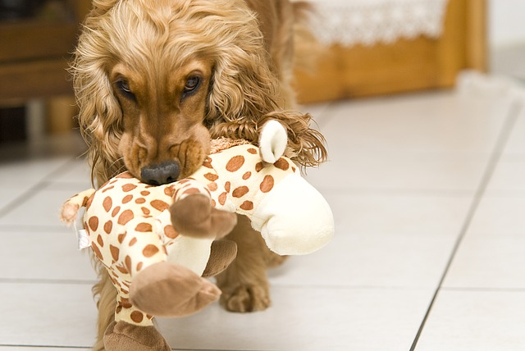

***Dog Care Duty***

What Is Needed To Take Care Of Your Best Friend

# Chapter 1:

***Dog Care Basics***

# Synopsis

The following are some of the basic care tips that every dog owner should put into practice.

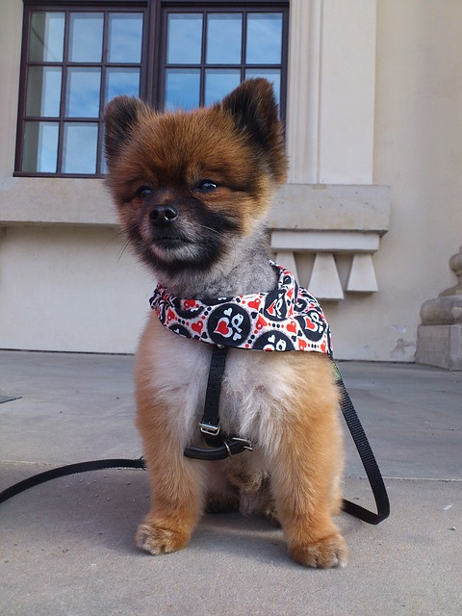

## Basic Information

Perhaps the first act of caring as an owner would be to provide the dog with a proper collar, preferably with the dog name and address clearly depicted on the collar. The collar chosen should be one that is safe and functional to ensure the dog is not undue stress when using it.

Bathing the dog regularly is also important. The frequency of the baths should be according to the lifestyle the dog keeps, and if unsure, the owner should seek the advice of a good vet. Bathing too frequently or infrequently enough, could have adverse results, such as skin problems, lack luster coat and hair fall or fur loss.

Designing a diet plan that is well rounded and complete is also another important point that should be looked into when trying to provide basic care for the dog. Improper diet plans can eventually end up costing the owner more, when there is a necessity to visit the vet often. A sick dog is often very unsetting and worrisome for the owner and certainly unpleasant for the dog too.

Providing the dog with the chance to exercise regularly is also another important basic requirement in caring for the pet. Without adequate exercise, the dog will not be able to have strong bones and a healthy body condition.

# Chapter 2:

***What Items Do You Need For Your Dog***

# Synopsis

In order to care for a dog well, there are several elements that need to be considered and provided for at all times. This will ensure that the dog is happy and well looked after and the owner is saddled with less dog related problems.



## The Essentials

The following are some of the essential items that would be ideal to have for the comforts of the dog:

• Dog food – some people make it a habit to give the dog table scraps and leftover food, this is really not good for the dog. A dog’s digestive system is different from that of a human, thus it requires a different diet plan. Ensuring the dog has proper food to eat that is specifically designed for animal consumption is better for the dog’s health and the owner’s wallet in the long run.

• Providing proper food containers, which the dog identifies as its own, is also important. This will help the animal to identify the food in it, as its own, and therefore be trained not to touch other food items, unless specifically allowed to do so.

• Grooming tools are also among the items that should be part of the caring kit for the dog. This is especially essential if the breed of the dog requires frequent grooming sessions. Having items such as brushes, nail clippers, wipes, fur clippers, shampoos and conditioners are all part of the normal regimen of grooming tools for a dog.

• Chew toys are also items to be included in the list, as these will keep the dog distracted and less likely to resort to destroying the owner’s things in the quest to satisfy its natural instinct to chew on anything and everything. It also helps to keep their teeth clean and alleviate any discomfort from teething problems.

**Chapter 3:**

***The Vet Is Your Friend***

# Synopsis

Finding a good and reputable vet whom the owner and dog can be comfortable with can sometimes be something of a challenge. However, if this scenario is found, then a good and beneficial relationship will prevail.

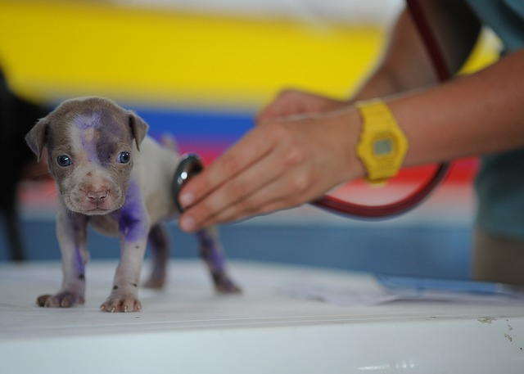**Don’t Avoid The Vet!**

The vet understands the deep bond that is usually formed between the owners and their pets, and therefore they are very delicate when coming to matters pertaining to the sick animal. The vet will be able to help the owner understand the problem and find a solution that is most suitable and acceptable to the owner, while all the while keeping the well being and comfort of the dog in mind. Most pet owner will stick to one vet as soon as a comfortable bond is formed.

As the animal cannot talk, the vet is trained to recognize and diagnose the problem accordingly, and then decide on the next course of action suitable for the given situation. Although this solution can sometimes be rather costly, the fact that there is a relationship formed over a period of time, the owner can be assured of getting the best rates possible. The owner can also be assured of the vet’s commitment and problem solving skills over time.

Most people will ask for recommendations from friends when it comes to finding a suitable vet for their pet. Arranging to meet with the vet without the pet present will allow the owner to get the feel of the doctor and the services provided. If the owner is satisfied with the outcome of the first meeting, then perhaps the services of the particular vet can be used.

This preview copy ends here and to get the full product, please go to (the website URL ).